

MobiVue PMMS

Ajanta Pharma Ltd.

Functional Specification Document (WMS_SAMPLING)

This document includes the functional and non- functional requirements for specification of the application designed for Ajanta Pharma.

BAR CODE INDIA, 145 Udyog Vihar Phase 1, Gurugram, Haryana-122016, PH: 0124 4337555 1

Prepared By: Leena

Version Number: 1.0

BAR CODE INDIA, 691 UDYOG VIHAR PHASE V, GURUGRAM, HARYANA - 122016, Ph.: 0124 4337555

# Notice

This document contains information, which is the proprietary property of Bar Code India. This document is received in confidence and its contents cannot be disclosed or copied without the prior written consent of Bar Code India.

Nothing in this document constitutes a guaranty, warranty, or license, express or implied. Bar Code India disclaims all liability for all such guaranties, warranties, and licenses, including but not limited to: Fitness for a particular purpose; merchantability; not infringement of intellectual property or other rights of any third party or of Bar Code India; indemnity; and all others. The reader is advised that third parties can have intellectual property rights that can be relevant to this document and the technologies discussed herein and are advised to seek the advice of competent legal counsel, without obligation of Bar Code India.

Bar Code India retains the right to make changes to this document at any time, without notice. Bar Code India makes no warranty for the use of this document and assumes no responsibility for any errors that can appear in the document nor does it make a commitment to update the information contained herein.

COPYRIGHT

Copyright © ***BCI*** 2023. All rights reserved.

TRADEMARKS

*Other product and corporate names may be trademarks of other companies and are used only for explanation and to the owners' benefit, without intent to infringe.

# Revision History

|  |  |  |  |  |
| --- | --- | --- | --- | --- |
| Revision Number | Date | Prepared By | Reviewed By | Comment |
| 00 | 22.05.2023 | Leena Patil | Sailendra Das | Functional & Design Specification document |

Table of Contents

Notice 2

Revision History 3

1 Protocol Approval 5

2 Introduction 6

3 Objective 6

4 Scope 6

5 Sampling 7

5.1.1 Cubicle Assignment 7

5.1.2 Cubicle Cleaning 9

5.1.3 Equipment Cleaning 12

5.1.4 Equipment Assignment 15

5.1.5 Line Clearance 17

5.1.6 Picking 20

5.1.7 Pre Staging 22

5.1.8 Staging 23

5.1.9 Sampling 24

5.1.10 Stage Out 26

# Protocol Approval

|  |  |  |  |  |
| --- | --- | --- | --- | --- |
| **M/S Bar Code India Ltd.** | | | | |
|  | **Name** | **Department** | **Designation** | **Sign & Date** |
| Prepared By |  | Software | Technical Document Writer |  |
| Reviewed By |  | Software | Business Analyst |  |
| Reviewed By |  | Software | Development Lead |  |
| Reviewed By |  | Software | Quality Tester |  |
| Approved By |  | Software | Software Quality Lead |  |

|  |  |  |  |  |
| --- | --- | --- | --- | --- |
| **Ajanta Pharma Ltd :-** | | | | |
|  | **Name** | **Department** | **Designation** | **Sign & Date** |
| Reviewed By |  |  |  |  |
| Reviewed By |  |  |  |  |
| Reviewed By |  |  |  |  |
| Reviewed By |  |  |  |  |
| Reviewed By |  |  |  |  |
| Reviewed By |  |  |  |  |
| Reviewed By |  |  |  |  |
| Approved By |  |  |  |  |

# Introduction

The purpose of this document is to list down all the system function solutions for the business need identified by the user.

# Objective

The Functional Specification Document is a document that provides detailed information on how the system solution will function and the requested behavior. The document is created based on the requirements identified by the user.

# Scope

This document will contain the functional details of the Mobivue PMMS system (Module-Sampling)

# Sampling

### Cubicle Assignment

**Activities**

|  |  |
| --- | --- |
| **Module Description** | This module will be used to assign cubicle for sampling of Raw material and Packing material against the Inspection Lot |

|  |  |
| --- | --- |
| **Pre-Conditions** | 1. Inspection Lot details needs to be imported from SAP. |

|  |  |
| --- | --- |
| **Process Steps** | 1. Enter the Material Code. 2. Select the Inspection Lot Number, Batch Number from the dropdown list. 3. Material Description will appear on the screen. 4. Click on Add button. 5. A grid format of, Line Item No, Cubicle Barcode, Material Code, Material Description, SAP Batch No, Quantity, UOM, Expiry Date, Retest Date, and Inspection Lot No will be displayed on the screen. 6. User will select checkbox of the Material from the list for which assignment is needed. 7. Select the Cubicle Code from dropdown; in which the material is to be assigned for sampling. 8. Cubicle Status for the material will be displayed. 9. Then click on Assign button. Details will be updated in data base. 10. By clicking on the close button user can return to the main screen. 11. The grid view will be display as Date, Group Code, Inspection Lot No., Group status, re-print and action. 12. User can take re-print of the closed group label by selecting the re-print icon. 13. Re-sampling of the materials against the inspection lot should allow up to the material release. 14. Inspection lot should remove i.e. not visible in drop down after material release against the inspection lot. 15. After re-test due of the material, SAP will create inspection lot against the material and push same to the BCI system. 16. Incase user wants to de-assign cubicle, select the material line from the list and click on De-Assign button. 17. Cubicle de-assignment cannot be done once line clearance of the cubicle completed successfully i.e. Line clearance verification completed. 18. But in case of the line clearance rejection, system should allow for the de-assignment of the cubicle. 19. De-assign cubicle can be assigned to other materials as per the requirement and proceed as per the procedure. |

|  |  |
| --- | --- |
| **Post-Conditions** | 1. Further process of sampling will be proceed. |

|  |  |
| --- | --- |
| **Validations** | 1. While creating group, system will validate material details data is imported from SAP. 2. An alert will be displayed in case of invalid Material Code is entered. |

### Cubicle Cleaning

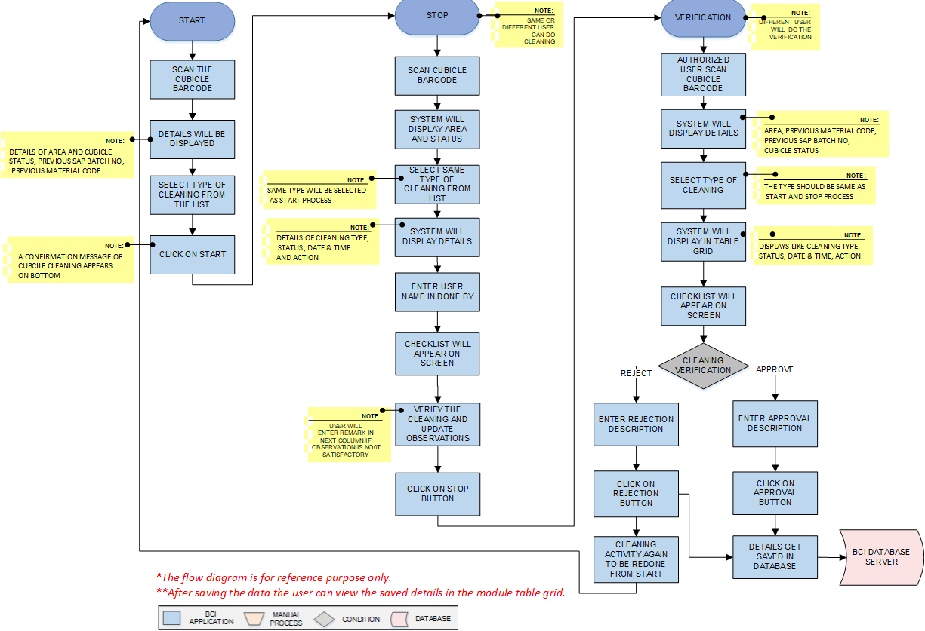

**Activities**

|  |  |
| --- | --- |
| **Module Description** | This module will be used for Cubicle cleaning process. |

|  |  |
| --- | --- |
| **Pre-Conditions** | 1. Cubicle status can be clean/unclean/not in use in system. |

|  |  |
| --- | --- |
| **Process Steps** | **Cubicle Cleaning Start: -**   1. User will scan Cubicle Barcode. 2. Area and Cubicle Status, Previous SAP Batch No, Previous Material Code, will be displayed on the screen. 3. Select the type of cleaning from the dropdown list. 4. Then click on Start button, system store as start time in database against the cubicle. 5. The Cubicle Cleaning added successfully message appears on bottom.   **Cubicle Cleaning Stop:** -   1. After cleaning procedure scan the Cubicle Barcode. 2. Selected Area and Cubicle Status will be displayed on the screen along with the previous SAP Batch No, Previous Material Code. 3. Select the same type of cleaning used for start from the dropdown list.   *\*Same Type will be selected as start process.*   1. System will display Cleaning Type, Status, Date & Time and Action Taken by user details in the table grid. 2. Enter cleaning done by person name. 3. Checkpoints will be displayed on the screen. 4. User will verify the cleaning and update observations in the checklist 5. After completing the check list, user will click on Stop button. 6. System will store date and time as cubicle cleaning stop time. 7. Cubicle cleaned stopped successfully notification will appear on the screen. 8. If cleaning is not satisfactory as per the checkpoints, user to enter the remark in the remark column.   **Cubicle Cleaning Verification:**   1. User will scan the Cubicle Barcode. 2. Area, Previous Material Code, Previous SAP Batch No, Cubicle Status will be displayed on the screen. 3. Select Type of cleaning from dropdown.   *\*The type should be same as Start and Stop process.*   1. System will display Cleaning Type, Status, Date & Time, and Action Taken By in the table grid along with cleaning done by person name box. 2. Checkpoints will be displayed on the screen. 3. Click on Is Verified Checkbox. 4. Enter the remark and user will click on Approve or Reject as per the requirement. 5. In case of cleaning verification rejection, cubicle status will be changed to uncleaned and system will not allow to use the cubicle. 6. After re-cleaning and satisfactory verification, cubicle can be used as per the requirement against the same group or other group as per the assignment. 7. In case of the cubicle cleaning rejection, the material can be assign to other cubicle after de-assign and sampling can proceed. 8. Click on Clear to clear all the details in the fields. 9. Click on Close to close the current cleaning window. 10. Data gets updated in the database |

|  |  |
| --- | --- |
| **Post-Conditions** | 1. Cubicle status will be changed to clean/uncleaned as per the verification. |

|  |  |
| --- | --- |
| **Validations** | 1. Sequence of cleaning will be followed as Cleaning Start, Cleaning Stop and Verification 2. An error message will be displayed in case of different cleaning type is selected. |

### Equipment Cleaning



**Activities**

|  |  |
| --- | --- |
| **Module Description** | This module will be used for Equipment cleaning process. |

|  |  |
| --- | --- |
| **Pre-Conditions** | 1. Equipment status should be unclean and not in use in system. |

|  |  |
| --- | --- |
| **Process Steps** | **Equipment Cleaning Start :-**   1. User will scan Equipment Barcode. 2. Equipment type (fixed/portable), Previous Material Code, Previous SAP Batch No, Area Barcode, and Status will be displayed. 3. Select the Equipment Cleaning Type from the dropdown list. 4. Then click on Start button. Details will update in database against the equipment. 5. Notification will be display for the cleaning start.   **Equipment Cleaning Stop: -**   1. User will scan Equipment Barcode. 2. Equipment type (fixed/portable)Previous Material Code, Previous SAP Batch No, Area Barcode and Status will be displayed on the screen. 3. Select the Equipment Cleaning Type from the dropdown list.   *\*Same type to be selected as the start process.*   1. System will display Cleaning Type, Status, Date & Time, Action Taken By 2. Enter the name of the person cleaning done by. 3. Checkpoints will be displayed on the screen. 4. User will verify the checkpoints and update the observations. In case of any non-conformance compulsory remark will be enter. 5. After completing the check list, user will click on Stop button. 6. System will store current date and time as cubicle cleaning stop time. 7. Notification will be display for the cleaning stop.   **Equipment Cleaning Verification:-**   1. User will scan Equipment Barcode. 2. Previous Material Code, Previous SAP Batch No, Area Barcode, Status will be displayed on the screen. 3. Select the Equipment Cleaning Type from the dropdown list.   *\*Same type to be selected as the start and stop process.*   1. System will display Cleaning Type, Status, Date & Time, and Action Taken By in grid format along with box displaying the cleaning done by person name. 2. Checkpoints will be displayed on the screen. 3. Click on Is Verified Checkbox. 4. Enter remark and user will click Approve or Reject based on observation. 5. After equipment verification rejection, equipment status will be changed to uncleaned. 6. System allow to re-clean the equipment in case of Rejection and do not allow to proceed next steps. 7. After satisfactory re-cleaning and cleaning verification the equipment can be re-use as per the user requirement in the same group or other new group as per the assignment. 8. Click on Clear to clear all the details in the fields. 9. Click on Close to close the current cleaning window. 10. Data gets updated in the database and SAP. |

|  |  |
| --- | --- |
| **Post-Conditions** | 1. Equipment assignment will be done. |

|  |  |
| --- | --- |
| **Validations** | 1. Sequence of cleaning will be followed as Equipment Cleaning Start, Equipment Cleaning Stop and Equipment Cleaning Verification 2. An error message will be displayed in case of different cleaning type is selected. |

### Equipment Assignment

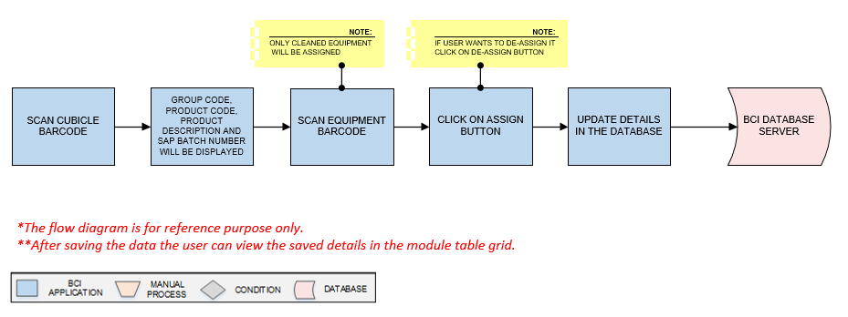

**Activities**

|  |  |
| --- | --- |
| **Module Description** | This module will be used for Equipment assigning process. |

|  |  |
| --- | --- |
| **Pre-Conditions** | 1. Equipment status should be clean in system. |

|  |  |
| --- | --- |
| **Process Steps** | **For Equipment assignment :-**   1. User will scan Cubicle Barcode in which equipment is placed. 2. The Group code, Product code, Product Description and SAP Batch Number will displayed on the screen. 3. User will scan Equipment Barcode which is applied on Equipment.   *\*Only cleaned equipment can be assigned.*   1. Click on Assign button, the equipment gets assigned to that cubicle. 2. Click on Clear to clear all the details in the fields. 3. Click on Close to close the current screen. 4. Save the details in database.   **For Equipment de-assignment :-**   1. User will scan Cubicle Barcode in which equipment is placed. 2. The Group code, Product code, Product Description and SAP Batch Number will displayed on the screen. 3. User will scan Equipment Barcode which is applied on Equipment. 4. Click on de-assign button, the equipment gets de-assigned from that cubicle. 5. Save the details in database. 6. Equipment de-assignment against the cubicle is not allowed after satisfactory line clearance i.e. Line clearance verification satisfactory. 7. But in case of the line clearance rejection, system should allow to de-assign the equipment/cubicle as per the user requirement. 8. De-assign equipment/Cubicle can assign to other materials as per the requirement. |

|  |  |
| --- | --- |
| **Post-Conditions** | 1. Equipment will be assigned to the cubicle. |

|  |  |
| --- | --- |
| **Validations** | 1. Unclean equipment should not allowed for the assignment. 2. Alert message will be displayed in case of invalid Cubicle Barcode is entered. 3. Alert message will be displayed in case of invalid Equipment Barcode is entered. |

### Line Clearance

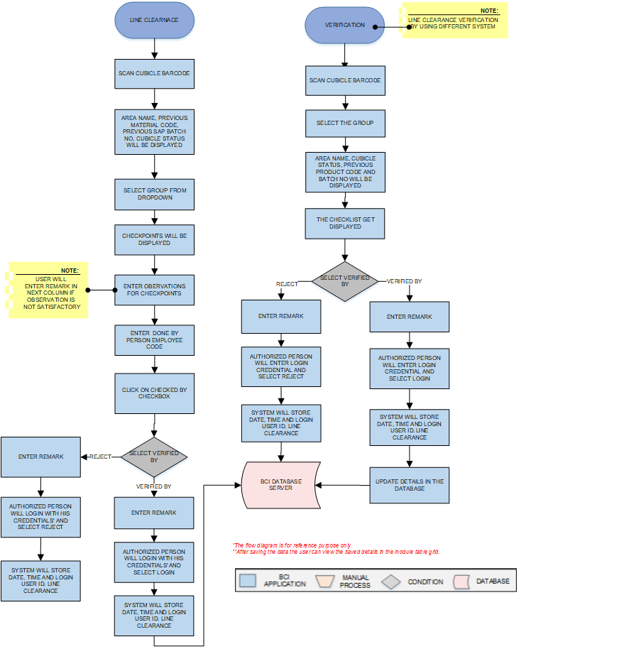

**Activities**

|  |  |
| --- | --- |
| **Module Description** | This module will be used for line clearance. |

|  |  |
| --- | --- |
| **Pre-Conditions** | 1. Cubicle and equipment status should be clean in system. |

|  |  |
| --- | --- |
| **Process Steps** | 1. **Line Clearance** 2. Scan the Cubicle Barcode. 3. Area Name, Previous Material Code, Previous SAP Batch No, Cubicle status will be displayed for the cubicle. 4. Select the Group from the dropdown list. 5. Checkpoints will be displayed on the screen. 6. User will check the points as per the checklist and update observation details~~.~~ 7. Enter the employee code of the done by person. System will display name of the person from system data base. 8. Click on Checked by checkbox. System will update checked by details as per the current system user details. 9. In case Line clearance verification done on same screen:-.   *\*On same screen, Authorized person will select Verified By, enter remark details and login with his credentials. System will store date, time and login user Id. Line clearance will be approved successfully on the same system by authorize user.*   1. Line clearance notification will appear on the screen. 2. In case of the line clearance rejection, authorized person will select verified by, enter the remark and its credential details. Then click on the rejection button. Line clearance notification will appear on the screen. System will not allow to proceed for the next processing step and it will allow for re-cleaning of the cubicle and equipment. 3. **Verification (In case by log in from different system)** 4. Scan the Cubicle barcode. 5. Select the Group from the dropdown list. 6. Area Name, Previous Material Code, Previous SAP Batch No, Cubicle status will be displayed for the cubicle. 7. System will display Action, Status, Time and Action Taken By in grid format. 8. Check points observation details will be display. 9. Then click on Verified By button. 10. Enter the remark details and login with his credentials. 11. The Line clearance notification will appear on the screen.   *\*If anything is found non satisfactory then user will click on Reject button.*  In case line clearance is completed, the cubicle /equipment cannot be de-assigned and cleaning of the cubicle/equipment cannot be started.  In case of the line clearance rejection, system will not allow to proceed the next step and it will allow to start the line clearance again from the initial user end.  In case of the line clearance rejection, system will allow to de-assign the equipment/cubicle as per the user requirement and start cleaning of the equipment/cubicle.  User can proceed the material in other cubicle/equipment/group as per requirement by assigning.  Data gets updated into the database.  Line clearance not required for the packing materials, Picking & Pre-staging activity can be performed before line clearance |

|  |  |
| --- | --- |
| **Post-Conditions** | 1. Line clearance will be completed. |

|  |  |
| --- | --- |
| **Validations** | 1. An alert should be displayed in case duplicate/ invalid Cubicle Barcode is entered. 2. An alert should be displayed in case duplicate/ invalid Cubicle Group is selected |

### Picking

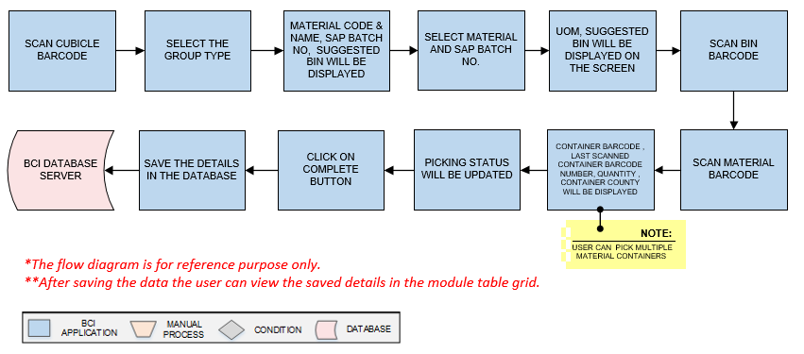**Activities**

|  |  |
| --- | --- |
| **Module Description** | The Module will be used to Pick material from Location and place in Pre stage area. |

|  |  |
| --- | --- |
| **Pre-Conditions** | 1. Group needs to be created. 2. Material is allocated in location. |

|  |  |
| --- | --- |
| **Process Steps** | 1. Scan the Cubicle Barcode. 2. User will select the Group from the dropdown list.(Only open groups will be visible here) 3. A grid format of Material code, Material Name, SAP Batch No, Suggested Bin will appear on the screen. 4. Select Material Code and SAP Batch No. from drop down list. 5. System will show the UOM of the material along with the suggested Bin code. 6. Scan the Bin barcode followed by Material Barcode. 7. After scanning of the Container Barcode, Last Scanned Container Barcode Number, Quantity, Container Count will display and picking status will be updated   *\*User can select multiple material containers during picking as per requirement*   1. Click on Complete button. 2. User will click on Clear button to clear the data. 3. User will click on Close button to close the picking. 4. Data gets updated in the database |

|  |  |
| --- | --- |
| **Post-Conditions** | 1. Material will be placed in Pre Stage area. |

|  |  |
| --- | --- |
| **Validations** | 1. An alert should be displayed in case duplicate/ invalid Cubicle Barcode is entered. 2. An alert should be displayed in case duplicate/ invalid Bin is entered. 3. An alert should be displayed in case duplicate/ invalid Material Barcode is entered. |

### Pre Staging

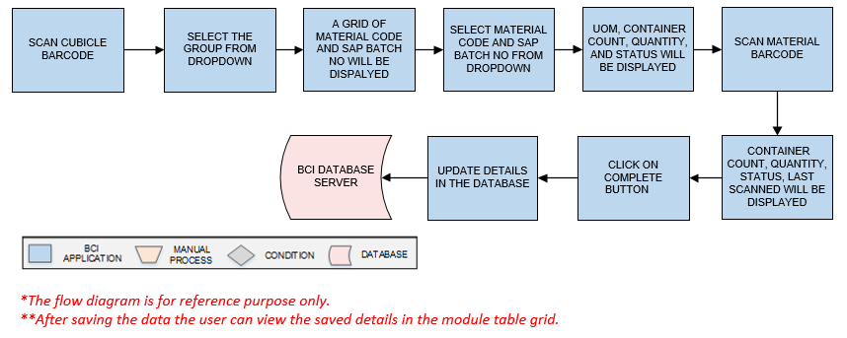**Activities**

|  |  |
| --- | --- |
| **Module Description** | This module will be used to validate material movement from pre staging area to staging. |

|  |  |
| --- | --- |
| **Pre-Conditions** | 1. Material Picking is completed |

|  |  |
| --- | --- |
| **Process Steps** | 1. Scan the Cubicle barcode. 2. Select the Group. A grid view of Material Code, Material Name and SAP batch no will be displayed. 3. Select material code and SAP batch no from the drop down. System will show the UOM of the material. 4. Then Scan Material Barcode. 5. Data will display in Last scanned container, Container count, quantity and status of the pre-staging details. 6. Click on Complete to successfully approve the pre-stage process. 7. User will click on Clear button to clear the data. 8. User will click on Close button to close the Pre staging. 9. System will updated as status as material pre staged. 10. Data gets updated in the database. |

|  |  |
| --- | --- |
| **Post-Conditions** | 1. Material pre- staging activity completed |
| **Validations** | 1. An alert should be displayed in case duplicate/ invalid Cubicle Barcode is entered. 2. An alert should be displayed in case duplicate/ invalid Material Barcode is entered. |

### Staging

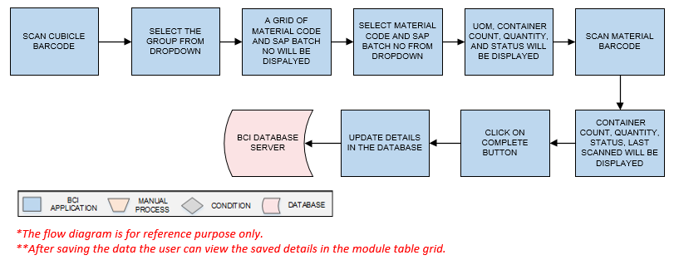**Activities**

|  |  |
| --- | --- |
| **Module Description** | This module will be used to validate material movement from staging area to Sampling. |

|  |  |
| --- | --- |
| **Pre-Conditions** | 1. Material pre-staging is completed. 2. Line clearance should completed (As per applicability of the materials ) |

|  |  |
| --- | --- |
| **Process Steps** | 1. Scan the Cubicle Barcode. 2. Select the Group. 3. Grid view of the Material code, Material Name and SAP batch no will display. 4. Select Material code, and SAP Batch No from the dropdown list. System will show UOM of the material. 5. Scan the material bar code, data will display in last scanned, Container count, Quantity and status of the staging. 6. Click on Complete to approve the staging. 7. User will click on Clear button to clear the data. 8. User will click on Close button to close the Pre staging. 9. Data gets updated in database. |

|  |  |
| --- | --- |
| **Post-Conditions** | 1. Ready to perform Sampling |

|  |  |
| --- | --- |
| **Validations** | 1. An alert should be displayed in case duplicate/ invalid Cubicle Barcode is entered. 2. Only pre-staged material can be scanned in Staging. |

### Sampling

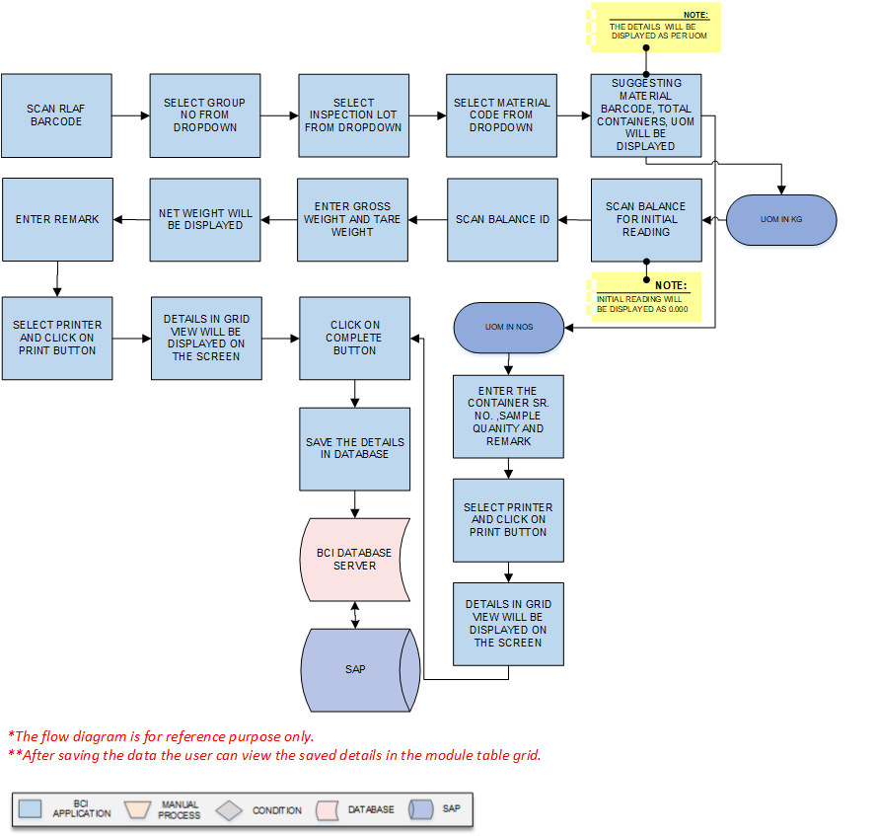

**Activities**

|  |  |
| --- | --- |
| **Module Description** | This module will be used to sampling of the material |

|  |  |
| --- | --- |
| **Pre-Conditions** | 1. Staging of the material is completed. |

|  |  |
| --- | --- |
| **Process Steps** | 1. Scan the RLAF Barcode. 2. Select Group Code, Inspection Lot No, Material Code and SAP batch no. from dropdown. 3. Suggesting Material Barcode, Total Containers will be displayed on the screen 4. UOM will be displayed on the screen.   **For the Material of which UOM is KG: -**   1. Scan material barcode and then Scan Balance barcode to capture initial zero reading of the balance. 2. Again Scan Balance barcode to capture the Tare weight and gross weight details. 3. Net weight will be displayed on the screen after auto calculation by the system from the gross weight & tare weight. 4. Enter Remark for sampling and system will display the compulsory use remark (If applicable, In case of the balance master if compulsory use remark was mentioned). 5. Select Printer from dropdown. 6. Click on Print button system will show grid view details. 7. A grid format of Sampling Barcode, Container Barcode, Material Code, SAP Batch No, Sample Quantity (Net Wt.), UOM, Done By, Remark, and Re-Print will be displayed on the screen.   **For the Materials of which UOM is Nos. :-**   1. Enter the container Sr. No. , Sample quantity in numbers and remark. 2. Select the printer from the dropdown list. 3. Then click on Print button then the label will be printed. 4. A grid view will be display Sr. No., Sampling Barcode, Container Barcode., Material code, SAP Batch No., Sample Quantity & UOM, Done by, remark and re-print. 5. After completing sampling for that material, user will click on complete button, system will update details in the data base. 6. User will click on Clear button to clear the data. 7. User will click on Close button to close the Sampling. 8. Data gets updated in the database and SAP. |

|  |  |
| --- | --- |
| **Post-Conditions** | 1. Sampled label will be generated. |

|  |  |
| --- | --- |
| **Validations** | 1. An alert should be displayed in case duplicate/ invalid RLAF is entered. |

### Stage Out

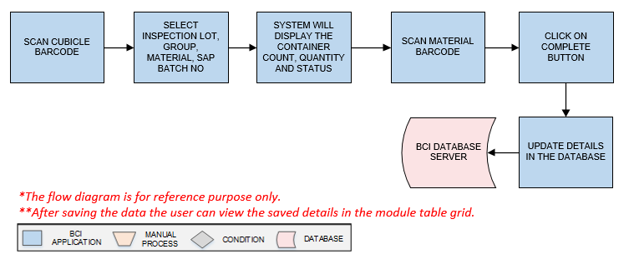

**Activities**

|  |  |
| --- | --- |
| **Module Description** | This module will be used to stage out the Material from cubicle. |

|  |  |
| --- | --- |
| **Pre-Conditions** | 1. Sampling should be completed |

|  |  |
| --- | --- |
| **Process Steps** | 1. Scan the Cubicle Barcode. 2. Select Group, Inspection Lot, Material, SAP Batch No from the dropdown list. 3. System will display the Container Count, Quantity and Status. for which stage out is required 4. Scan Material Barcode for loose material which is to be reallocated. Details will be updated as per material. 5. Click on Complete button. 6. User will click on Clear button to clear the data. 7. User will click on Close button to close the Stage Out. 8. Data gets updated in the database and SAP. 9. System can allow stage out of the material after sampling completion of the containers only but sampling of the inspection lot may completed or may not completed at that time. |

|  |  |
| --- | --- |
| **Post-Conditions** | 1. Container will be removed from the cubicle. |

|  |  |
| --- | --- |
| **Validations** | 1. An alert should be displayed in case duplicate/ invalid Cubicle Barcode is entered 2. An alert should be displayed in case duplicate/ invalid Material Barcode is entered. |